**Eight textures for eight planets in solar system**

Mars Jupiter Earth

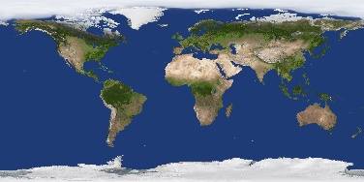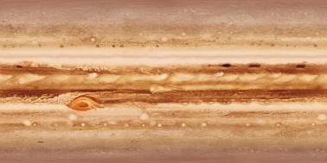

Mercury Saturn Uranus

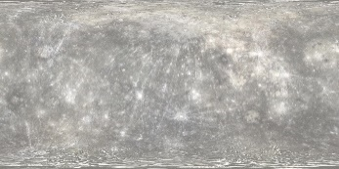

Venus Neptune

